A) Objectives  
 The goal of this lab was to create a system that would play a song over a speaker. The microcontroller used SPI to interface with a DAC chip which sent analog voltages to a speaker amplifier. The software is required to use a data structure to store the music in memory. This makes the song notes more intuitive to access.

B) Hardware   
 See last page for the schematic.

C) Software  
 Our code was submitted to Blackboard. The data structure we used was an array of structs where each struct contains the number of cycles for the note length and the cycles between interrupts for frequency.

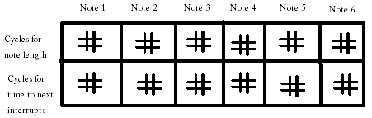

The call graph and data flow graph are the same, so we did not draw those.

D) Measurement Data  
Resolution = 4.28 – 3.72 /(3500 – 3000) = .00112 V  
Range = 5.00 - .04 V = 4.96 V  
Precision = 12 bits  
Accuracy = 100 x actual / ideal = 100( .00112 \* 2500)/3.08 = 90.9%

0 = 40 mV  
500 = 600 mV  
1000 = 1.24 V  
1500 = 1.88 V  
2000 = 2.44 V  
2500 = 3.08 V  
3000 = 3.72 V  
3500 = 4.28 V  
4096 = 5.00 V

It takes 257 cycles for one interrupt which 7.5% of the CPU time while outputting a 440 Hz sine wave.

The maximum current required to run the system is 250 mA and the average current is 180 mA while the music is playing.  
The current required to run the system without the music is 115 mA.

E) Analysis and Discussion  
1. Some errors with the DAC is the accuracy, the zero-voltage-output, and the nonlinearity. Because the accuracy is only 90%, the tuning of notes may be off. The zero-voltage-output reduces the range as well as gives a good indication of the amount of error which causes a reduction in accuracy. At some points the DAC does not give a perfectly linear output which adds noise into the output sine wave.  
  
2. For this lab which uses the DP512 and TLV5616, the maximum baud rate of the DP512 gives a setup and hold time above the minimum for the DAC chip. Therefore, we can use the maximum baud rate without any trouble.  
  
3. The frequency range of a discrete spectrum analyzer is determined by the FFT algorithm. The range of an analog one is determined by the variable band-pass filter inside the analyzer.

4. The purpose of the MC34119 is to amplify the current because the TLV5616 cannot supply enough current to drive a speaker.